

Open Road Press

**Author Bios**

Title: *Wheels of Wisdom: Life Lessons for the Restless Spirit*

Tim and Debbie Bishop have coauthored four books about their midlife launch into marriage, cross-country bicycle touring, and other matters of faith and inspiration. *Two Are Better: Midlife Newlyweds Bicycle Coast to Coast* captures the story behind the stories, while *Bicycle Touring How-To: What We Learned* shares their knowledge with bicycle touring wannabes. Now, *Wheels of Wisdom: Life Lessons for the Restless Spirit* conveys some deeper truths that apply to virtually any life pursuit. *Metaphors in Motion: Wisdom from the Open Road* is an e-book containing more lessons like those found in *Wheels of Wisdom*.

The Bishops serve as volunteer Hope Coaches for [TheHopeLine](http://www.thehopeline.com/), a nonprofit organization that seeks to reach, rescue, and restore hurting teens and young adults. They are available for speaking engagements about their touring and life experiences. The couple blog at [www.openroadpress.com](http://www.openroadpress.com).

**Tim Bishop**

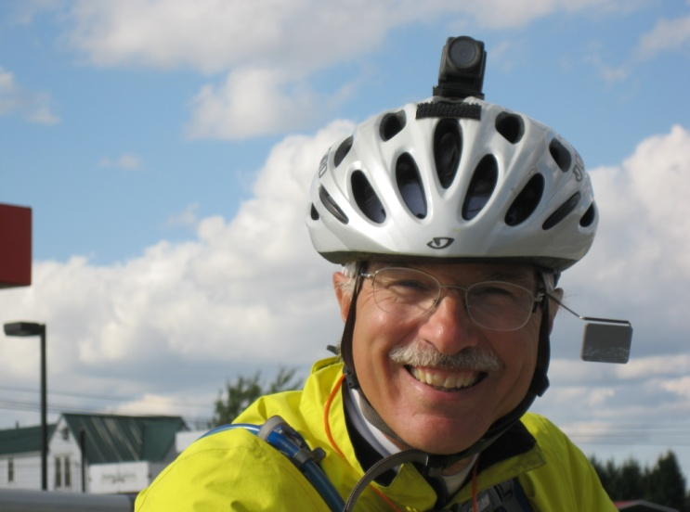In addition to consulting for small businesses, Tim Bishop has written *Hedging Commodity Price Risk: A Small Business Perspective*, an e-book that explains hedging in easy-to-understand language. He is a CPA and former corporate treasurer with over thirty years of business experience, and blogs at <http://hedging.openroadpress.com>. Tim is a native of Houlton, Maine.

**Debbie Bishop**

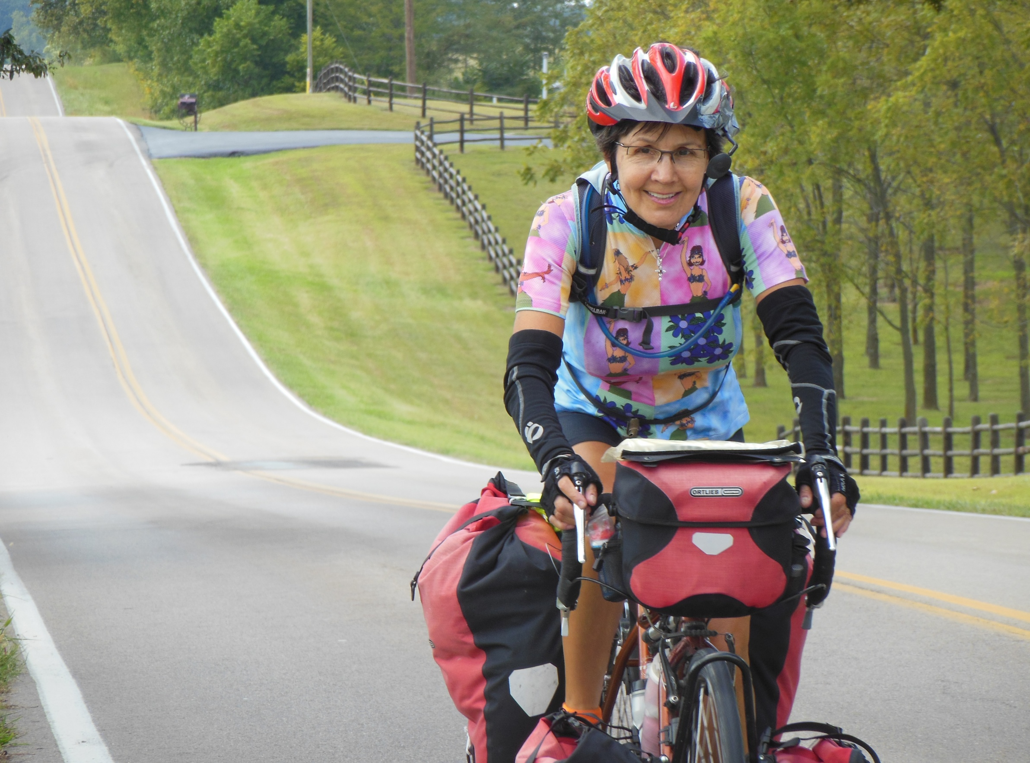Debbie Bishop has taught for over twenty-eight years. She has a passion for reading and seeing that young people do it well. She also has a strong interest in recovery issues and encouraging others with her own triumphs over such struggles earlier in her life. She is a featured author in *Love is Out There* by Melissa Williams-Pope, in which she relates her own story of finding love later than most. Debbie volunteers as a facilitator for [www.findingbalance.com](http://www.findingbalance.com), an online support group dedicated to helping women who are struggling with eating disorders. She also has New England roots.