**FOR RELEASE FROM JUNE 1, 2023 TO JUNE 19, 2023**

Media contact: Tim Bishop at 207-217-0302 or [tbishop@openroadpress.com](mailto:tbishop@openroadpress.com)

**New Novel Maps Escape from Depression**

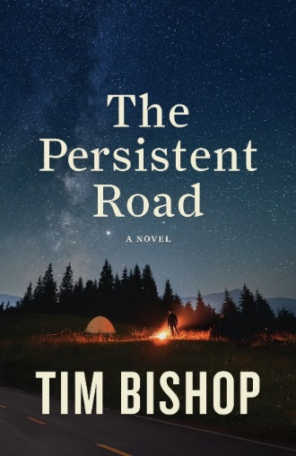***Five award-winning authors endorse Tim Bishop’s debut novel***

THOMPSON’S STATION, TENNESSEE – June 1, 2023 – On June 20, 2023, Open Road Press will release *The Persistent Road*, a novel about a man who suffers loss and embarks on a bicycling odyssey to find out if life is still worth living.

“Call it a midlife crisis or an epic adventure,” author Tim Bishop said. “My protagonist is empty and lacks purpose. As a coach, I see people like him frequently, and the pandemic deepened their despair. Before my character gives up on life, I nudge him out of his ‘discomfort zone.’ He starts in California and pedals north, where he encounters not only hills and valleys on his bicycle but also his inner demons.”

The content in Bishop’s book is no accident. He and his wife, Debbie, have bicycled throughout America and discovered adventure and intrigue off the beaten path. For over a decade, Bishop has coached people who struggle with serious life issues, first on TheHopeLine.com and now with NeedHim.org. Award-winning author Katie Shands called his novel “hope on paper.”

Ace Collins, past winner of the prestigious Christy award for Christian novels, said, “*The Persistent Road* is a beautifully written story of tragedy and triumph.” *USA Today* bestselling author Patricia Bradley said the book “will draw you in and keep you turning the pages. It's a book I'll read again and again.” Bishop’s book has also been endorsed by award-winning novelists Katie Powner and Lisa Lickel.

Beth Patch, senior editor/producer for CBN.com, said, “Expect a wonderful but intense journey on two wheels, one that is both difficult and freeing.” And Chris Carpenter, managing editor of Crossmap.com, a division of *The Christian Post*, said, “This book is not only an engaging celebration of the human spirit but an insightful reminder that God can create miraculous outcomes even when all seems lost.”

After 10,000 miles of bicycling, Bishop cowrote *Wheels of Wisdom* with his wife. The book, which *Publishers Weekly* dubbed “a road map for life,” earned four first-place awards in inspirational and Christian genres. A University of Maine graduate and resident of Tennessee, Bishop was a corporate treasurer before becoming an author and a coach. Learn more at [TimBishopWrites.com](https://timbishopwrites.com/).

The 368-page paperback edition of *The Persistent Road* retails for $17.99 and can be preordered at a discount from the publisher before June 20. Booksellers can acquire it through Ingram. The e-book retails for $9.99, with discounts before release. Professional reviewers may contact [OpenRoadPress.com](https://www.openroadpress.com/) for a complimentary review copy or obtain one from [NetGalley.com](https://www.netgalley.com/) before publication.

**###**