**HOLD FOR RELEASE UNTIL OCTOBER 31, 2025**

Media contact: Tim Bishop at 207-217-0302 or [tbishop@openroadpress.com](mailto:tbishop@openroadpress.com)

**Open Road Press Rolls Out Bicycle Adventure Series Book 2**

***The Road Unveiled follows Tim Bishop’s award-winning debut novel***

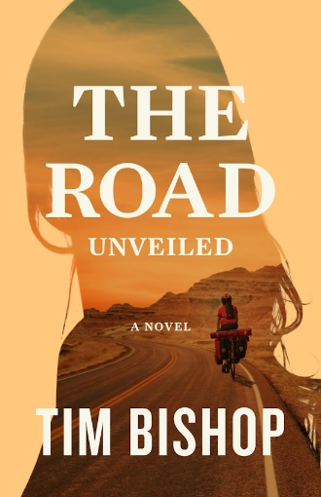THOMPSON’S STATION, TENNESSEE – October 1, 2025 – On November 4, 2025, Open Road Press will release *The Road Unveiled*, a contemporary Christian novel about two singles who bicycle the Great American West. Lauren Baumgartner, a former missionary to Uganda, is anticipating deeper love and a family after her farewell to the single life ends at the Atlantic Ocean. Doug Zimmer, a recent widower at sixty, begins to realize he’d rather not live life alone.

“You won’t have an engaging story if your protagonist doesn’t face obstacles,” author Tim Bishop said. “After Lauren and her fiancé break up, the travel challenges heat up. Cycling through Yellowstone National Park, a motorcycle rally with its outlaws, and an Indian reservation with youth gangs can cause trouble for an attractive and fearless woman. And she is nothing but daring.”

“But more compelling than the travel drama is what’s going on inside Lauren. And Doug. She’s beset with a secret—like many of us—and it’s keeping her from embracing a love that can lead to the family she so desires. Doug is caught in the middle, wanting his travel partner’s dreams fulfilled but unsure whether he can or should be part of them. With three possible suitors on stage and Lauren’s life in peril, *The Road Unveiled* becomes a story of sacrificial love on multiple levels.”

*USA Today* bestselling author Patricia Bradley agrees. “I had eagerly awaited the follow up to *The Persistent Road*, and Tim Bishop did not disappoint me. *The Road Unveiled* captured my heart with its timeless story of love, friendship, loyalty, and a journey on roads I now want to travel.”

The first novel in Tim Bishop’s Bicycle Adventure Series, *The Persistent Road*, received endorsements from five award-winning authors and garnered the 2024 Ames Award in General Fiction. According to its website, “The Ames Award acknowledges excellent books that encourage living a courageous and obedient Christian life, especially under challenging circumstances.”

The content in Bishop’s books is no accident. He and his wife, Debbie, have bicycled throughout America and discovered adventure and intrigue off the beaten path. The couple coauthored *Wheels of Wisdom*, which *Publishers Weekly* dubbed “a road map for life.” It earned four first-place awards in inspirational and Christian genres. Bishop also coaches people online who struggle with serious life issues.

A University of Maine graduate and resident of Tennessee, Bishop was a corporate treasurer before becoming an author and a coach. Learn more at [TimBishopWrites.com](https://timbishopwrites.com/).

The 388-page paperback edition of *The Road Unveiled* retails for $18.99. Booksellers can acquire it through Ingram. The e-book retails for $9.99. Request a review copy at [OpenRoadPress.com](https://www.openroadpress.com/).

**###**